GRADE | 10 | SUBJECT |  | CAT |  | WEEK |  | W4  L6 |  | TOPIC | Solution Development: Word Processing: Tables Layout
LESSON SUMMARY FOR:
DATE STARTED |  |  |  |  |  |  | DATE COMPLETED
LESSON OBJECTIVES |  |  | At the end of this lesson the learner must be able to:  - Know how to insert Rows and Columns in a table  - Adjust row and column heights  - Work with Header rows
TEACHER ACTIVITIES |  |  |  |  |  |  |  |  | LEARNER ACTIVITIES |  |  |  | TIMING | RESOURCES NEEDED
1. Methodology  - Hands on classroom activity  - Power point presentation  - Text book  2. Introduction  Revise table properties  A table is a structure of vertical columns and horizontal rows with a cell at every intersection. A Word table can contain as many as 63 columns but the number of rows is unlimited.  3. Main Body (Lesson presentation)  Add a Row  - Click a row where you want to add an additional row and then click Layout tab  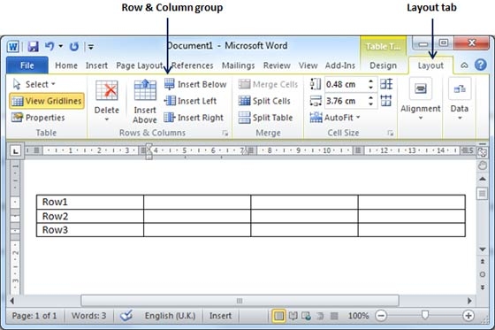  - Use Row & Column group of buttons to add any row below or above to the selected row. If you click Insert Below button, it will add a row just below the selected row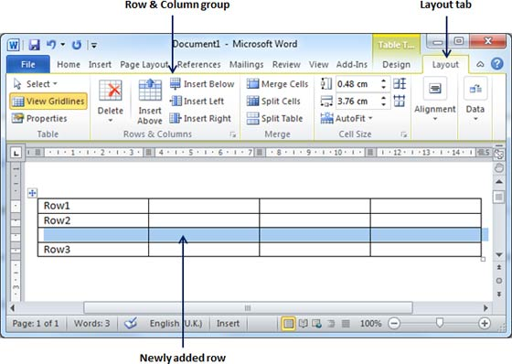  If you click Insert Above button, it will add a row just above the selected row  The same applies to adding a column  Delete a Column:  The steps to delete columns from a table of a word document.  Step (1): Click a column which you want to delete from the table and then click Layout tab to have following screen.  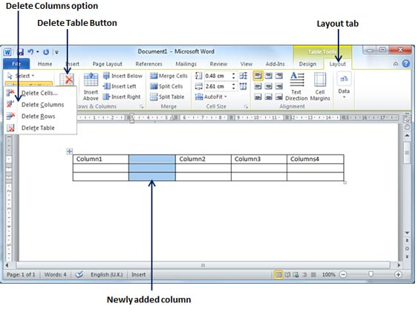  Step (2): Click the Layout tab, and click Delete Column option under the Delete Table Button to delete the selected column.  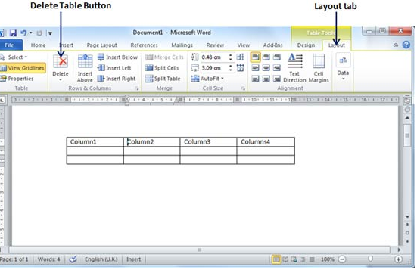  Header Rows  When you work with a very long table, it will be divided into several  pages. It may be necessary to make adjustments to the table so  that the table headings appear on each page.  NOTE: Repeated table headings are visible only in Print Layout  view or when you print the document.  - Select the heading row or rows. The selection must include the first row of the table.  - Under Table Tools, on the Layout tab, in the Data group, click Repeat Header Rows.  Source:  http://www.tutorialspoint.com/word_2010/word_rows_columns.htm  4. Conclusion  Let learners experiment with all aspects introduced |  |  |  |  |  |  |  |  | Folder DataFiles_Solutions for learners to practice |  |  |  | Introduction and definition 10 minutes  The rest of the time allocated on explanation of the lesson | PowerPoint presentation  Data projector  Prescribed Textbooks  Computers  Part of your Life  p.  Via Afrika  p.  Focus  p.

Name of Teacher: HOD:
Sign: Sign:
Date: ______________________________________ Date:

